Kevin Dawson

Juneteenth and 401 Years of American Freedom, 1619-2020

Juneteenth, also known as Freedom Day and Jubilee Day, was first celebrated on June 19, 1866 as an annual event to commemorate the abolition of slavery in the United States. It has, for 154years, invited Americans to remember our 401-year commitment to freedom and equality, while reminding us of the precariousness of Black freedom. If we reflect more deeply, Juneteenth calls upon us to consider the many contributions that African Americans have made to this country.
The abolition of slavery that resulted in African American freedom and citizenship occurred through a piece-meal and prolonged process extending over several years. Slavery was indeed abolished on December 18, 1865; however, white Southerners refused to recognize Black freedom and citizenship far beyond that date. The Emancipation Proclamation (January 1, 1863), freed slaves in all territories that were “in rebellion against the United States” during the American Civil War (April 12, 1861—May 9, 1865). The Thirteenth Amendment (December 18, 1865) abolished slavery everywhere in the United States. The Fourteenth Amendment (July 9, 1868) extended citizenship to the formerly enslaved, granting them equal protection under the law. The Fifteenth Amendment (February 3, 1870) prohibited the Federal and State governments from denying or abridging Americans citizens the right to vote “on account of race, color, or previous condition of servitude.”
Despite the Emancipation Proclamation, the 365,000 Union soldiers who sacrificed their lives to preserve the Union and abolish slavery, and ratification of Constitutional amendments; many Southerners refused to recognize Black liberation and citizenship. After the Civil War, many enslavers residing in remote places simply refused to inform tens-of-thousands of African Americans that they were now free, extracting unrequited wealth from their minds and bodies for months and even years. Texans, living on the periphery of the United States, were especially adept in this ruse. Consequently, Union soldiers occupying the South made public declarations, informing African Americans that they were, in fact, free. On June 19, 1865 Union general Gordon Granger read General Order, Number 3 in Galveston, Texas, stating that “all slaves are free. This involves absolute equality of personal rights and rights of property between former masters and slaves.” Juneteenth was first celebrated one year later in communities throughout Texas, and the commemoration continued to spread to Black communities throughout the United States, becoming the most popular celebration of the abolition of slavery in a country zealously devoted to freedom. Yet, as a country that takes great pride in its commitment to freedom, America refuses to recognize one of its greatest contributions to freedom—the liberation of some four million enslaved people on its own soil. We intentionally forget Juneteenth, as it complicates and nuances who we imagine ourselves to be, as a country.
History is made and remade as each generation weighs its values against the circumstances of the past that created their present. Memories are formed, willfully forgotten, rediscovered, and reimagined. We, as Americans, create historical memories about our inception; the origins of American freedom, liberty, and equality; and who we are as a people. Our official history remains rather flat, unnuanced, and triumphant. It begins when Pilgrims established Plymouth Colony in November 1620. Fleeing English and Dutch religious persecution aboard the Mayflower, Pilgrims began America’s experiment in Democracy, which was nurtured during the Colonial Period, and honed by the Founding Fathers. Gun-ownership is central in this narrative. Like the staff of Moses, guns in the hands of Americans divinely protected American freedom from Britain (our oldest and strongest ally) while serving as a warning to those who would establish a tyrannical government.
Popular versions of American history willfully forget slavery; forgetting that the first enslaved Africans arrived in English North America in August of 1619, one year before Pilgrims began their social experiment that included a fraught relationship with the Wampanoag peoples who they steadily displaced. Claims that America is “the land of the free,” forget that America was a slave-owning country for 246 years, slavery has only been abolished 156, and, that during the later period, Jim Crow racism and systemic institutionalized racism has precluded true equality. We forget slavery’s central role in colonization, with enslaved Africans providing the overwhelming majority of labor necessary to exploit the Americas. We forget the African wisdom that captives provided to enslavers and how it made the tropical production of cash crops—sugar, indigo, rice, tobacco, chocolate, coffee, and cotton—extremely profitable… for enslavers. In this regard, we forget that from 1500 to 1820 the Atlantic slave trade forcibly transplanted some 12 million enslaved Africans into the Americas, with roughly 800,000 imported into what became the United States. During this same period, only 2.5 million Europeans arrived in the Americas. We assume that most of the wealth produced in colonial America was generated in Northern colonies, New York, Massachusetts, or Rhode Island. But we forget that in South Carolina enslaved Africans introduced African rice-growing traditions, making South Carolina the wealthiest of the thirteen colonies and the wealthiest state in the U.S up until the Civil War. We equally forget that slave traders and planters were the wealthiest Americans, and slave-produced cotton made the Mississippi Valley the wealthiest region in Antebellum (1800-1860) America. Likewise, we forget that guns were, more often than not, implements of injustice, used against American Indians and enslaved Africans to protect white Americans from the repercussions of the tyranny they allegedly produced. Whites used guns to drive American Indians from their homelands and to kill them, creating space for plantation slavery. Enslavers used guns to protect themselves against slave rebellions while heavily armed slave catchers served as proxy militias, tracking down escapees, meeting out extralegal justice, and deterring freedom struggles.
American history fails to recognize that American freedom was defined against the harsh realities of American slavery. In many important ways, the enslavement of Africans, not British tyranny, inspired Early Americans to become more devoted to the ideals of freedom, liberty, and (white) equality than any other country. Captives’ whip-scarred bodies, whose movements were tightly regulated, stood in stark juxtaposition to the freedoms enjoyed by white Americans; serving as constant reminders of the loss of freedom and the privileges and rights enjoyed by white citizens. Indeed, many of the Founding Fathers’ understandings of freedom, including those of John Jay, Thomas Jefferson, George Washington, John Madison, Benjamin Franklin, and Alexander Hamilton, were informed by their ownership of human beings or in other ways they benefited from and interfaced with enslaved Africans.
For 401 years our national bearing has been amiss, and the recognition of Juneteenth can help us find its bearing. We, as a nation, remain shackled to the slave trade and slavery; adrift in a sea of systemic institutionalized racism that dispossesses, marginalizes, and exploits people of color while privileging white Americans. Instead of erecting monuments commemorating the abolition of slavery, Americans chose to edify Confederate generals and politicians—traitors who fought against freedom, liberty, and equality. Likewise, Americans chose to hang Confederate battle flags from state capital and city hall buildings; using flags and statues as mechanisms for inflicting racial subjugation, akin to Klu Klux Klan hoods.
The consequences of historical racism are not confined to the past; its legacy continues to inform our current circumstances, living alongside contemporary racism. White Americans continue to benefit from the genocide of Native Americans and the enslavement of Africans while African Americans and Indigenous peoples continue to suffer. For 401 years, slavery, segregation, and racism have conspired to disadvantage African Americans. Generations of wealth produced by Black minds and bodies went not to Black Americans but to their enslavers; constructing strong foundations of white privilege. Following the Civil War, a century of segregation prevented African Americans from competing with white Americans for desirable jobs and housing, while ensuring that their labor continued to benefit and enrich white Americans. Institutional racism continues to create barriers to education and employment. Today, African Americans suffer from inadequate health care and housing, and are plagued by disproportionately high rates of police violence, health issues, and incarceration. The consequences of racism are also felt in perhaps more subtle ways. Denied access to swimming pools and swim lessons, African Americans are six times more likely to drown than white Americans, which the US Center for Disease Control has deemed an “epidemic.”
African-descended people in America have been committed to freedom for 401 years. We can continue to ignore Juneteenth, or, in the midst of an unfaltering nationwide Black Lives Matters movement, we can use Juneteenth as a catalyst for helping to remember our national commitments to freedom, liberty, and equality and implement policies that advance these ideals. As part of this process, and as our country removes statues of colonizers and Confederate generals, we can choose to honor the abolition of slavery by erecting tributes to freedom where shrines to tyranny once stood. If we truly are a freedom loving country, then a day commemorating the liberation of 4 million Americans should be one of our most important national holidays, not an event requiring essays, like this one, to explain its meaning.

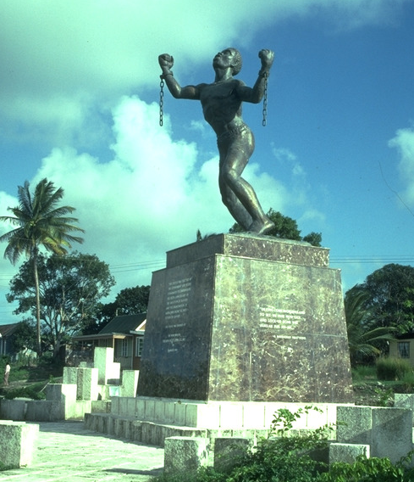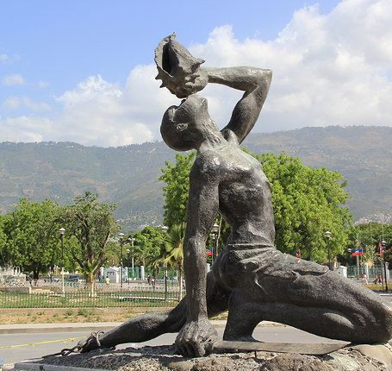

“Emancipation Monument,” Barbados  Karl Broodhagen (1985) |  | “Le Marron Inconnu” or “The Unknown Slave,” Haiti  Albert Mangonès (1967)
This statue was commissioned by the government of Barbados to commemorate the 150th anniversary of slave emancipation in the British colonies. It was unveiled in March 1985. |  | The above Haitian statue is of a maroon (rebellious slave) who helped Haitian slaves first secure their freedom and then independence from France during the Haitian Revolution (1791—). Wearing a broken shackle on his left leg, he holds a sugar knife (weaponized against enslavers) in his right hand, and a blows conch shell, which were used for long distance communication and to coordinate military actions during battles.
During the twentieth century, and at roughly the same time monuments commemorating Confederate generals and politicians were erected across the South to reinforce racial subjugation, Caribbean nations commissioned monuments commemorating liberation and freedom.

